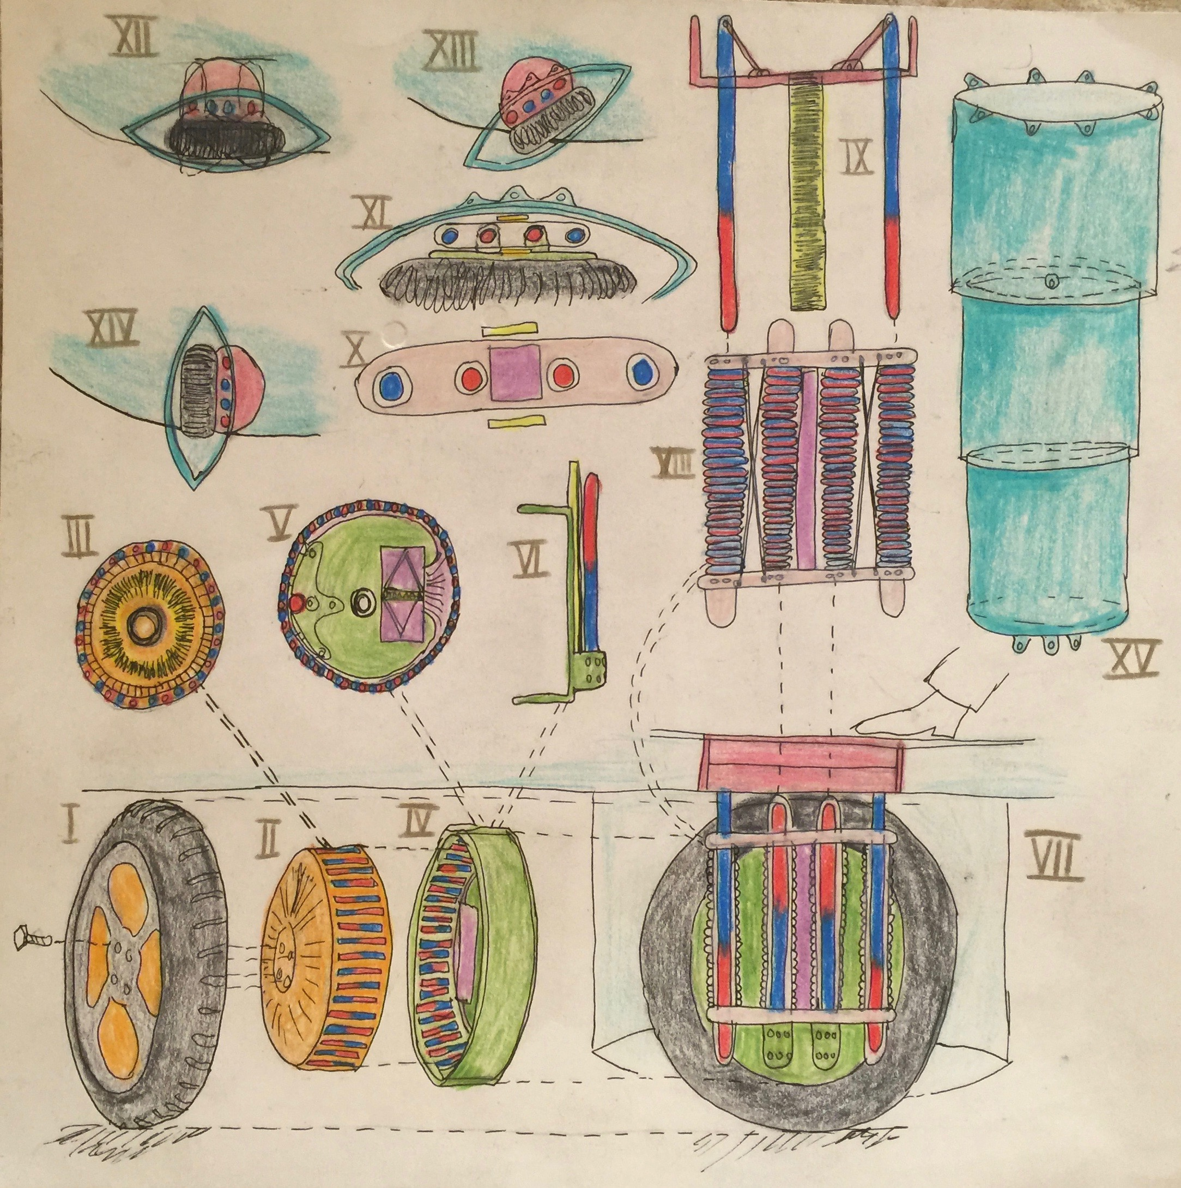Klima Ko-op

Week ending 13 Mar 2016

Wheel Progress Report

# Achieved Mon 7 Mar – Sun 13 March 2016

* A week of lots of learning and little progress!

# Bothe rations

|  |  |  |  |  |
| --- | --- | --- | --- | --- |
| Problem | | Observations | | Solution - Plan |
| 3D Printer not printing – flow of filament halts. Currently the nozzle is jammed, and attempts to extrude cause the nozzle assembly to move about 1mm in –Z (not good) | | Appears to be due to Z-axis bed levelling not being accurate, along with bumps in the glue on the bed. These cause a pinching off of the molten filament flow. I researched having digits2widgets print the parts but they do not do the necessary volume | | I’ve purchased an auto-bed-levelling kit for the 3D Printer. It uses a Z axis sensor to automatically adjust the head. Its been shipped. |
| Coil winding is not htat even, both in rows and layers. | | Had good discussed with David about solutions. I researched automatic coil winders but they are prohibitively expensive (£1K+) | | Am building a wooden jig to hold longer 6mm core / rod in drill grips. Have purchased lubricant to slide off wound coils. There is a Youtube of this approach. Needs care not to dissolve or damage the varnish on coils. |
| High Voltage Board – yes there is switching of LEDs going on, but there is a smell of overly hot electronics! And the full H bridge switching under Arduino control isn’t happening. | | Researched that my circuit of 4 x NPN s is too naïve (they use it in India schools!). Measured voltages and currents – not right. | | Have ordered PNPs for the top two transistors for each of the 12 banks. |
| Melting scissors as done last week clearly runs risk of blowing up transistors and Arduino. | Verified that I hadn’t blown up Arduino – I had blown the software off it. | | Flyback diodes and opto-isolaters are the standard solution – ordered and delivered!. I’ve also ordered a fire extinguisher for electricals! | |

I’ve also been installing and beginning to use and learn an electronic circuit design tool called KiCad (open source).

I’m still jolly excited by the electric jerrycan – I propose to put two runs of 108 cells (for 400v) in each jerry can, so each has 216 cells – to give a minimally tolerable miles per jerrycan. Capacity 4000mAh x 3.7v = 14.8 watt hours per cell = 1598 watts per 108 cells, but that is only about 6 miles. The 216 cells would yield 3197 watts or 12.8 miles. You can always use more than one jerrycan, daisy chaining them together. At 45g per cell x 216 cells is 9.7kg or 21.4 lbs. So its about the weight of a 10 litre jerry can, liftable by someone of average to less than average strength (who is not strong). My previous design had removable battery packs, three to a car each being 174mm tall x 108mm wide x 2470mm long (longer than a person). My new design keeps that 174 x (3 x 108 = 324mm) with a shorter length. Or 174mm tall x 108 mm wide with a shorter length – we essentially need 18 of these in the car, or in banks of 3 that is 6 flaps in the floor to open. So by the passengers feet are 2 of the 6, in the boot 1 and by the drivers feet 3. They are a flap in the floor that lifts up and you put the batteries in. They plug into the car with 400V DC, via a cover that pushes aside

I’ve done lots of sketches to optimise the fit of the circuitry on the high voltage board, but realise I’ve got to get the circuit exactly right before making it fixed.